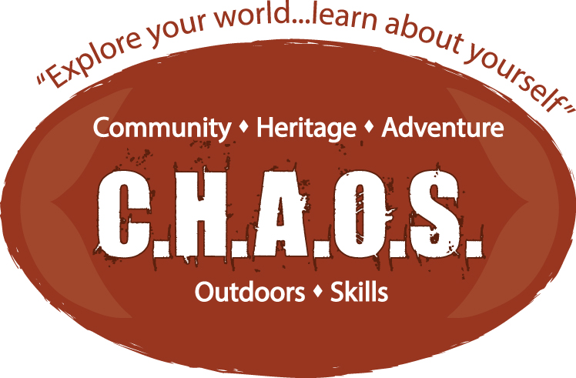
CHAOS 11
Community, Heritage, Adventure, Outdoors and Skills 11

- Application Deadline: January 29th, 2024
- Interviews will be held during the weeks of February 5 – 14, 2024
- All applicants will be notified of the outcome of their application on or before February 21st, 2024

Application Form for CHAOS 11

To apply, you need to send your completed package to:

- Wood Street Centre, 411 Wood St., Whitehorse, YT Y1A 2E9 or…
- Email a scanned copy to applications-wsc@yukon.ca

Your application package includes:

- Fully completed application form
- Personal Correspondence
- Reference Package

Program is Spring Semester only!

Personal Correspondence:

Please submit a handwritten letter of introduction. In your letter, you are asked to provide some background information telling a bit about yourself. In addition, please include why you are interested in participating in CHAOS 11, as well as what you expect to gain from a semester in the program.

Student Commitment:

Students are expected to participate in all aspects of the program including all planned activities and trips.
By signing up to be enrolled in CHAOS 11, you are expressing an interest in challenging, and pushing yourself as well as being a cooperative and active member of the group.

NOT ALL PARTS OF THIS PROGRAM ARE EASY, AND STUDENTS SHOULD NOT EXPECT IT TO BE

For more information, please call (867) 667-8413 or visit our website at:
http://woodstreetcentre.yukonschools.ca/

